Database Project Assignment 1: Business Idea

* Introduce the company/organization you are going to be making a database for. What does the company do? What do they sell? What do they provide their customers? Where is it? How many employees? Are there different departments within the business?
* 1 page, 12 pt font, single spaced
* Upload your file to Moodle, GitHub, and summarize your assignment highlights on Flipgrid!

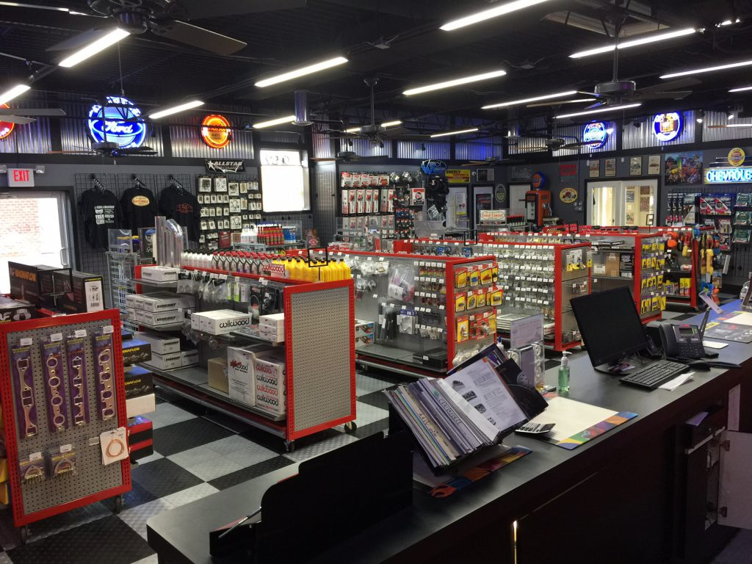This company, named Little Jimmy’s Performance Parts and Co, which based in Chicago, will be responsible for distributing and selling motorcycle (and maybe auto stuff too if the owner, named Jimmy, is back from vacation to give it the green light) parts to its online and retail branches.

This establishment provides their customers, which consist of your do-it-yourself Joe and mechanics throughout the Chicagoland area. They have retail stores ranging from Elmwood Park to Downers Grove. They currently have 6 store fronts with each store having 4 full-timers and 2 part-timers, which in total have 24 full-timers and 12 part-timers. Across all the non-retail departments consist of 15 more employees, three per department, which adds to a total of 51 employees. This company has a total of 5 departments: Human resources, operations management, marketing management, financial management, and information technology management. Human resources will keep track of their employee’s and payroll. The database will contain info about the employee’s first and last name, their address, their positions, if they’re hourly or salary, benefits and they amount they are paid.

Operations management will keep track of inventory. Such parts include the type of bike, the type of part such as the exhaust, body, controls & mirror, bike protection, seats, foot controls and pegs, and windscreens. They will also carry riding gear such as helmets, jackets, pants, gloves, boots, and riding suits.

Marketing will keep track of current and past promotions for the retail and online platform, and the financial will be responsible for keeping track of financial records and other money related stuff, such as gross and net revenue, debts, assets & liabilities, and other stuff that goes on a balance sheet. IT will keep track of the ticketing system implemented throughout the company which keeps tabs on the POS systems, real estate issues, corporate computer issues, other issues.